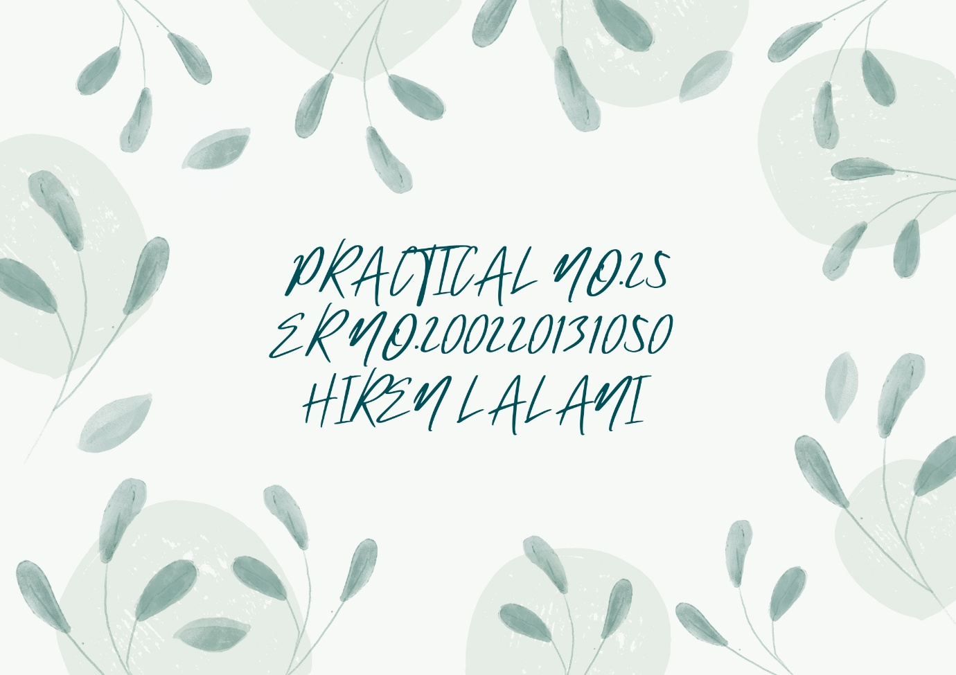

PATRICIAL NO 25

Aim :-- Write a program to replace a character in given string

#include <stdio.h>

#include <string.h>

void replacechar (char \*s, char c1, char c2)//define a function

{

int i = 0;

for (i = 0; s[i]; i++)

{

if (s[i] == c1)

{

s[i] = c2;

}

}

}

int

main ()

{

char s[1000], c1, c2;

printf ("Enter the string : ");

gets (s);

printf ("Enter a character replace: ");

c1 = getchar ();

getchar ();

printf ("\nEnter character to replace with %c : ", c1);

c2 = getchar ();

printf ("\n before replace:%s", s);

replacechar (s, c1, c2);//call the function

printf ("\nafter replace:%s", s);

return 0;

}

